
Corporate Membership
Access Fore Golf
- Access to KGC course
  - 4 players per day
  - Weekends after 12noon
  - If an AFG member wants to play at the weekend before 12noon (and there is availability) they can but will have to pay the members guest rate
  - AFG players can book for themselves and bring along up to 3 (three) guests at the members guest rate
  - Bookings to be made by phone to the pro-shop
  - Bookings can be made 7 days in advance
  - Bookings are subject to availability
  - You must present your AFG ID card before being able to play. No Card = No Play, or Play with the relevant guest fee

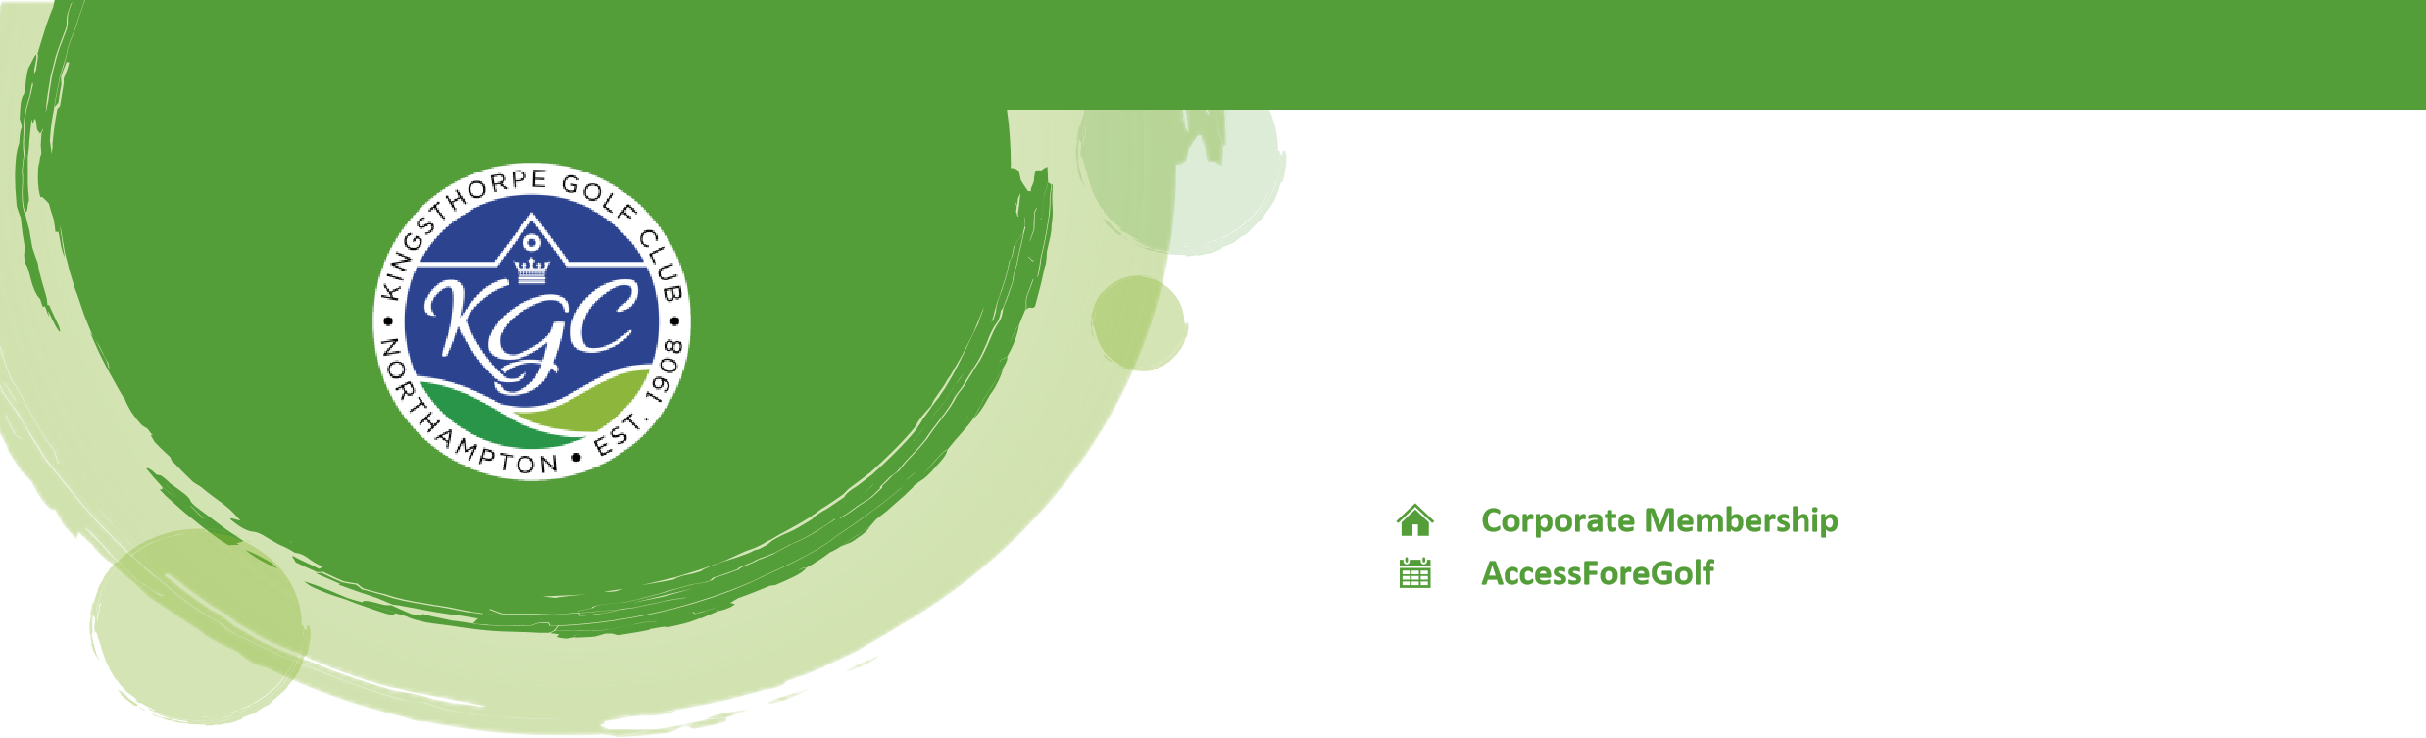

- Access to rollups & mid-week competitions
  - As per any other booking, please call the pro-shop and book your tee slot
  - You will not be allocated a set tee time for the roll-ups and Tuesday evening competitions as these competitions are turn up and play with who you are drawn to play with.
  - If the AFG player allocation has already been filled/ booked for that day, you can still join in, but will have to pay a member guest fee before playing

- Contact details
  - 01604 711173

- Discounts at KGC for AFG members (only available with your AFG ID card)
  - Bar – 10% (on drinks only)
  - Buggies – Members rental rate

